# Chapter 7: Current Electricity

**All Lectures Uploaded on YouTube:** [**https://tinyurl.com/fkm10-physics**](https://tinyurl.com/fkm9-physics)



## 16.1 Electric Current

**The time rate of flow of electric charges through a cross-sectional area is called electric current.** 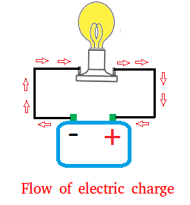

Electric current is produced due to the flow of either positive or negative charges or sometimes both. For example, the current in metals is due to flow of negatively charged electrons.

Electric current is produced due to the flow of either positive or negative charges or sometimes both. For example, the current in metals is due to flow of negatively charged electrons.

Electric current is defined as the rate of flow of electric charge through a conductor. It is given by the formula:

$I=\frac{ΔQ}{Δt}$, where:

* **I** = Current (**Ampere, A**)
* **Q** = Charge (**Coulomb, C**)
* **t** = Time (**seconds, s**)

The **SI unit** of current is the **Ampere (A)**, which is equal to one Coulomb of charge flowing per second.

1 milliampere = 1 mA = 10-3A

1 microampere =1 pA = 10-6A

One ampere current in terms of flow of charge is stated as “when one coulomb of charge flows through any cross-sectional area in one second”.

### 16.1.1 Conventional Flow of Current

By convention, electric current is considered to flow from the positive terminal of a power source to the negative terminal, even though electrons actually flow in the opposite direction. This is known as the conventional flow of current.

Current flowing from positive terminal to negative terminal of a battery due to the flow of positive charges is called conventional current.

Conventional current produces the same effect as the current flowing from the negative terminal to the positive terminal due to the flow of negative charges.

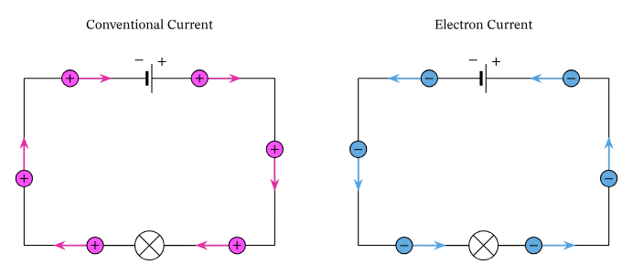

### 16.1.2 Electrical Conduction in Metals

In metals, conduction occurs because of the presence of free electrons. These electrons move randomly, but when a potential difference is applied, they drift towards the positive terminal, forming an electric current.

The net movement of these free electrons in one direction creates what we call an electric current. So, the electrical conduction in metals happens because of the movement of free electrons when an electric field is applied across it, creating an electric current.

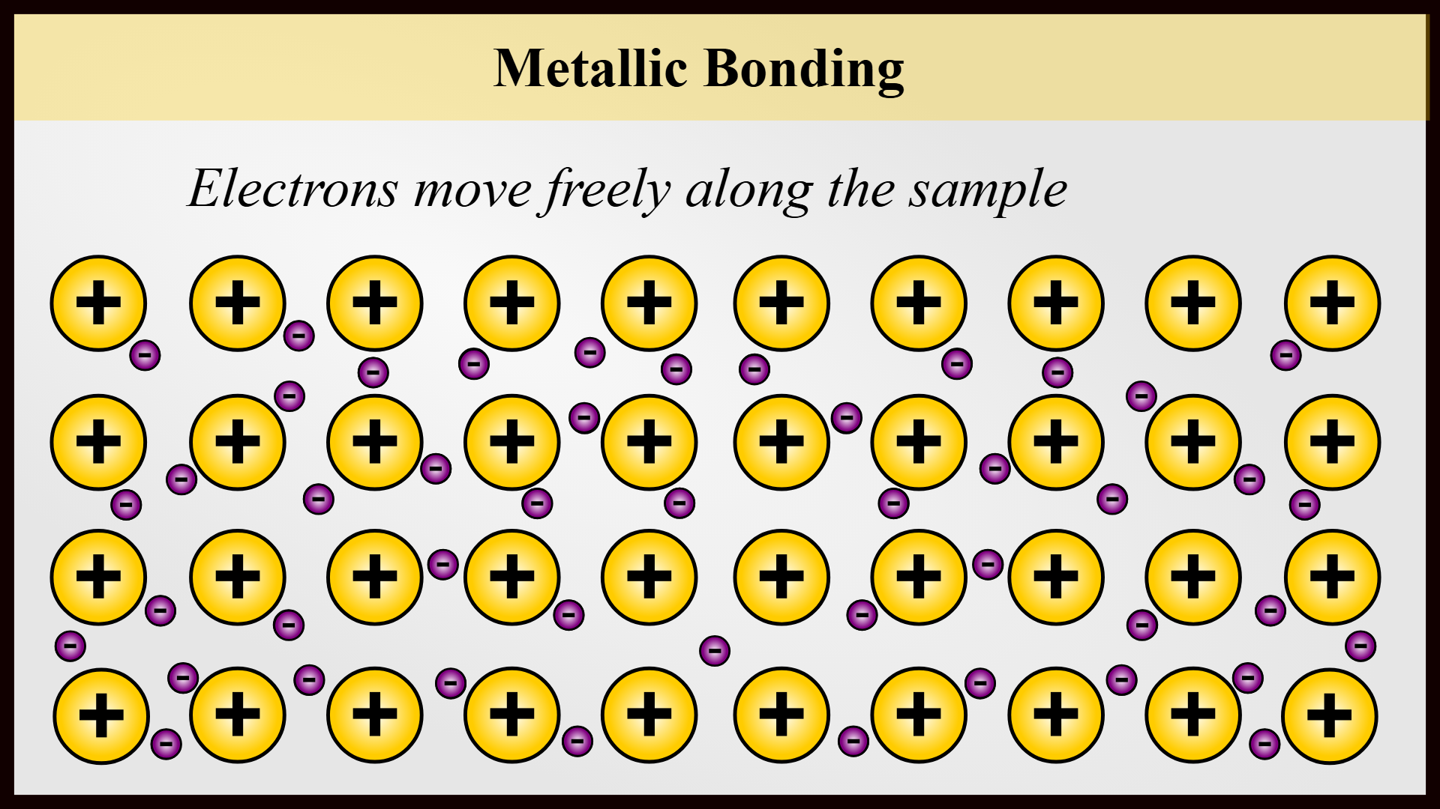

## 16.2 Alternating and Direct Current

Electricity flows in two ways; either changing direction called alternating current (AC), or in a fixed direction called direct current (DC). Electricity or “current” is nothing but the movement of charges (electrons here) through a conductor, like a wire.

In DC, the electrons flow steadily in a single direction, or “forward.” Direct current may be steady (i.e., uniform) or varying as shown in the figure.

In AC, electrons keep switching directions, going “forward" half the time and going "backward" the other half time. The direction of current in the circuit depends upon the changing polarity of the alternating voltage source.

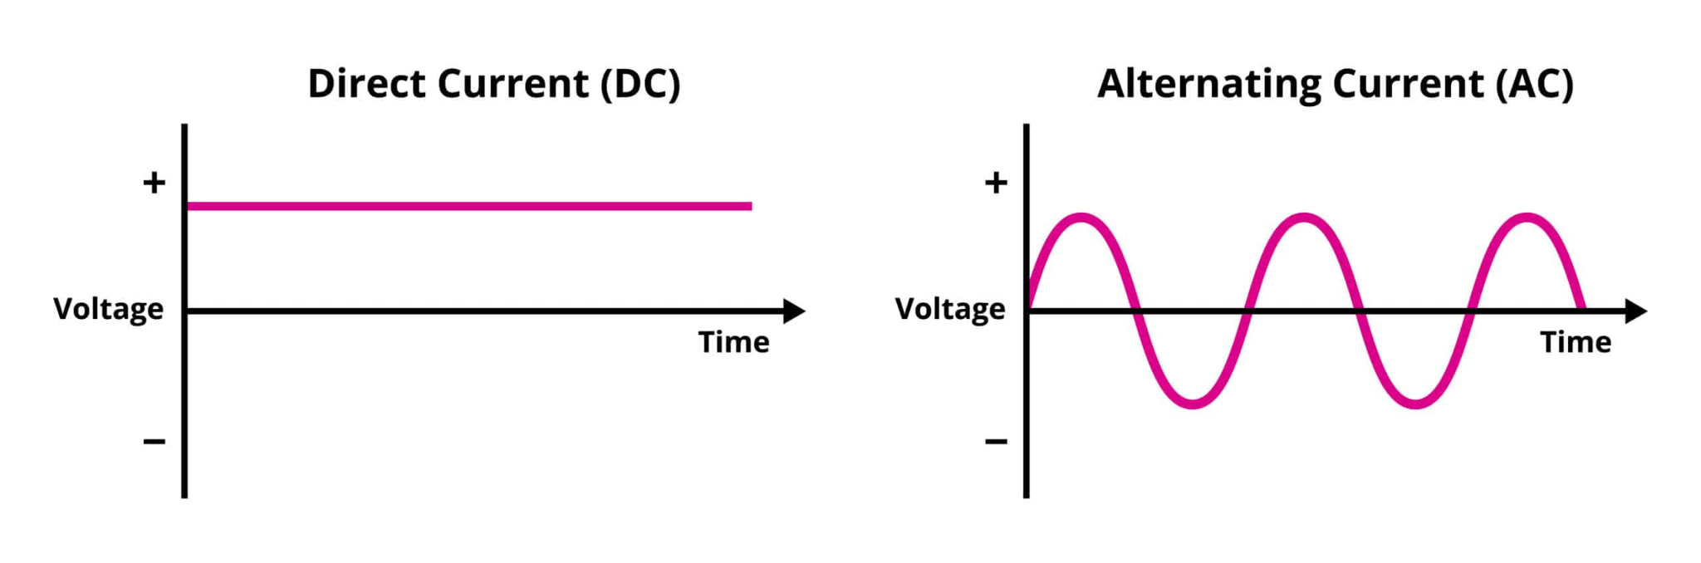

**Direct Current (DC):** The flow of electric charge in one direction only. Example: battery supply.  
**Alternating Current (AC):** The flow of electric charge periodically reverses direction. Example: household electricity supply.

Illustration: Graph showing AC as a sine wave and DC as a straight line.

## 16.3 Potential Difference

**The difference of electric potential between two points is called potential difference.**

Potential difference is defined as the work done to move a unit charge from one point to another. It is given by the formula:

$V=\frac{W}{Q}$, where:

* **V** = Potential difference (**Volt, V**)
* **W** = Work done (**Joule, J**)
* **Q** = Charge (**Coulomb, C**)

The **SI unit** of potential difference is **Volt (V)**. One volt of potential difference is defined as “when a potential energy of 1 joule is needed to move a charge of 1 coulomb from one point to another inside the field”.

Conventionally, the positive terminal of a battery is at higher potential while negative terminal is at lower potential. So, the end of a circuit component connected to the positive terminal will be at higher potential as compared to the other end connected to the negative terminal of the battery.

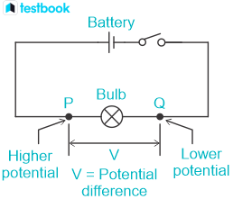

## 16.4 Electromotive Force (EMF)

**The energy supplied by a battery per unit positive charge when it flows through the closed circuit is called electromotive force (EMF).**

Electromotive force (EMF) is the total energy supplied by a source to move unit charge through the circuit. EMF source is a device which converts non-electrical energy into electrical energy, and is required in a circuit to maintain a constant potential difference across its components, i.e. devices.

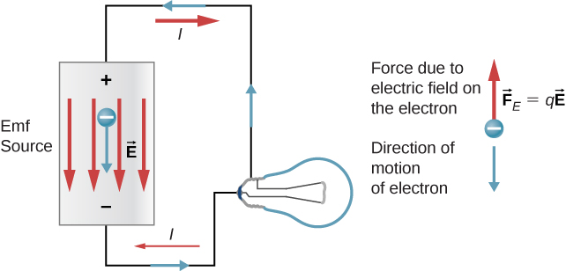

It is given by the formula:

$E=\frac{W}{Q}$, where:

* **E** = EMF (**Volt, V**)
* **W** = Work done (**Joule, J**)
* **Q** = Charge (**Coulomb, C**)

**The SI unit of EMF is Volt (V)**.

The SI unit of electromotive force is the same as that of electric potential as $\frac{J}{C}=V$. Examples of em sources are batteries (convert chemical energy into electrical energy), solar panels (solar to electrical), thermocouples (thermal to electrical) and generators (mechanical to electrical).

Illustration: Diagram of a battery supplying emf to a circuit.

## 16.5 Ohm's Law

Ohm's law states that the current passing through a conductor is directly proportional to the potential difference applied across it, provided temperature and other physical conditions remain constant. If ‘V’ is the potential difference across the two ends of a conductor, then current ‘I’ will flow through it. Mathematically:

It is expressed as $V=IR$, where:

* **V** = Potential difference (**Volt, V**)
* **I** = Current (**Ampere, A**)
* **R** = Resistance (**Ohm, Ω**)

**The SI unit of resistance is Ohm (Ω).**

Ohm's law is not applicable to all devices. It can only be applied to certain devices, mostly metals, which are called ohmic devices. Examples of ohmic devices are copper and silver wires and resistors. Devices which do not obey Ohm's law are called non-ohmic devices. Examples of non-ohmic devices are filament bulb, thermistor and semiconductor diode.

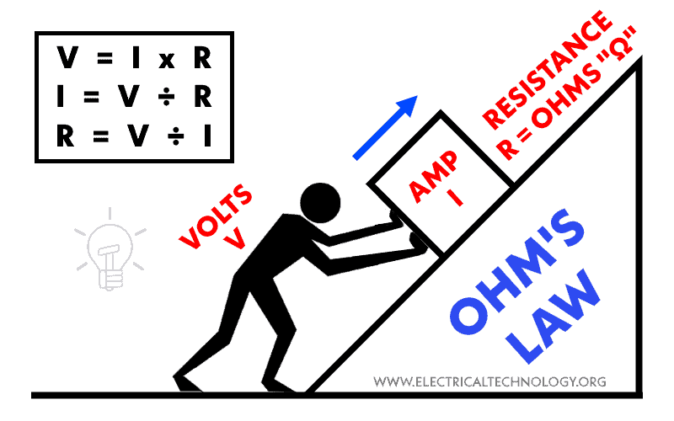

### 16.5.1 Limitations of Ohm's Law

Ohm's law does not apply when physical conditions such as temperature remain unchanged. It fails for devices like diodes and transistors where the V-I relationship is non-linear.

### 16.5.2 Ohmic and Non-Ohmic Devices

**Ohmic devices:** Devices that obey Ohm's law (**V ∝ I**). Example: metallic resistors.  
**Non-ohmic devices:** Devices that do not obey Ohm's law. Example: filament lamps, diodes.

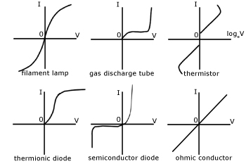

The graph of the filament bulb shows that current saturates as the current is increased and at large values even a large change in voltage ‘V’ will show small change in current ‘I'. T

The graph of the thermistor shows that resistance decreases sharply thus at a large value even a small change in voltage ‘V’ will show a large change in current ‘I’.

Semiconductor Diode graph also deviates very strictly from the straight line voltage ‘V’ and current ‘I’ relationship. In fact most modern electronic devices, such as transistors, have nonlinear current-voltage relationships; therefore they are non-ohmic.

## 16.6 Resistance

**Resistance is defined as ‘the opposition to the flow of charges’.**

Resistance is the opposition offered by a material to the flow of electric current. It is given by the formula:

$R=\frac{V}{I}$, where:

* **R** = Resistance (**Ohm, Ω**)
* **V** = Potential difference (**Volt, V**)
* **I** = Current (**Ampere, A**)

The following are used for a wide range of resistance values:

1 kilo - ohm = 1 kQ = 103 Ω   
1 mega - ohm = 1 MQ = 106 Ω

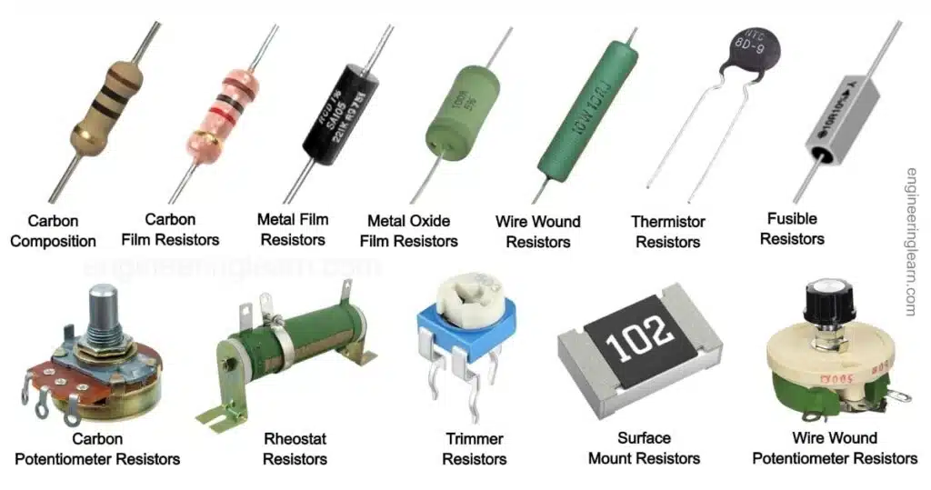

### 16.6.1 Length of Wire

The longer the wire, the greater the resistance, because electrons collide more frequently.

(**R ∝ L**)

### 16.6.2 Cross-sectional Area of Wire

A thicker wire has lower resistance because more electrons can flow simultaneously.

(**R ∝ $\frac{1}{A}$** )

### 16.6.3 Temperature

As temperature increases, resistance increases due to greater lattice vibrations, depending upon the nature of the material.

In case of insulators and semiconductors, the resistance decreases as the temperature increases because the thermal energy will generate more charge carriers.

(**R ∝ T**)

### 

### 16.6.4 Material Nature of Wire

The resistance of a body also depends upon the nature of material. Its value changes from material to material. Usually, insulators have greater resistivity while conductors have smaller. Different conductors have different resistivities depending upon their internal structure.

**Example:** Tungsten has high resistance, making it suitable for bulbs.

Illustration: Resistance characteristics of tungsten wire.

## 16.7 Resistivity

Specific resistance or resistivity $ρ$ of a material is the resistance offered by a wire of length 1 m having cross- sectional area 1 m2.

Resistivity is a material-specific property that defines how strongly a material opposes current flow.

It is given by the formula:

$ρ=R\frac{A}{L}$, where:

* **ρ** = Resistivity (**Ohm-meter, Ωm**)
* **R** = Resistance (**Ohm, Ω**)
* **A** = Cross-sectional area (**m²**)
* **L** = Length of conductor (**m**)

### Table: Resistivities of Some Materials at 20°C

| **Resistivities of Some Materials at 20°C** | |
| --- | --- |
| **Material** | **Resistivity (Ωm)** |
| Copper | 1.7 × 10⁻⁸ |
| Aluminum | 2.8 × 10⁻⁸ |
| Iron | 1.0 × 10⁻⁷ |
| Nichrome | 1.1 × 10⁻⁶ |

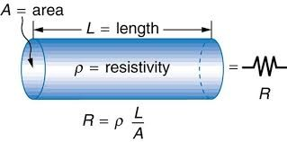

### 16.7.1 Temperature Dependence of Resistivity

As temperature increases, the resistivity of metals increases due to enhanced atomic vibrations, while in semiconductors, resistivity decreases as more charge carriers are generated.

It is found that for normal temperatures the change in resistivity ‘ $ρ_{o}$’ at 0°C and ‘ $ρ_{T}$’ at T°C is directly proportional to:

1. Initial resistivity
2. Rise in temperature T

- **∝** , which gives us

- **=**

Where **‘ $α$’** is the constant of proportionality and is called **temperature coefficient of resistivity**. Its value depends only upon the nature of material. Mathematically:

$α$**= $\frac{ρ_{T}-{ ρ}_{o}}{ρ_{o}ΔT}$**

The units of temperature coefficient of resistance or resistivity are °C-1 or K-1. For common metals, **‘ $α$’** typically has a value of 0.003 to 0.005 °C-1. That is, an increase in temperature of 1C° increases the resistance by 0.3% to 0.5%.

Interestingly, the temperature coefficient of resistivity is negative for semiconducting materials. This means that, unlike metals, the resistivity of semiconductors decreases with increasing temperature.

## 16.8 Electrical Measuring Instruments

### 16.8.1 Ammeter

An ammeter is used to measure current in a circuit. It is always connected in series. The range of an ammeter is usually from milliamperes (mA) to several amperes (A). When you are measuring current in your home appliances, usually an ammeter with ampere values ranging from 1A to 100 A is used.

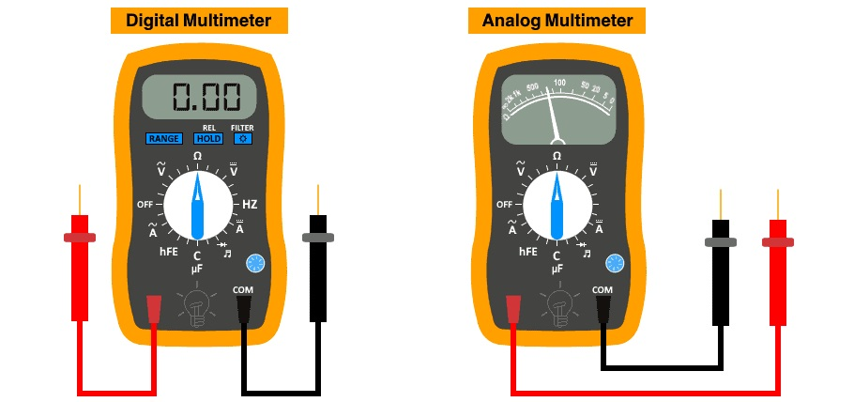

Since the ammeter must be able to make measurements by disturbing the current in the circuit as little as possible, ammeters are designed to have as low a resistance as possible.

### 16.8.2 Voltmeter

A voltmeter is used to measure potential difference across two points in a circuit. It is connected in parallel across components. To measure the potential difference, voltmeter must be connected in parallel with the component across which the potential difference is to be measured. The range varies from millivolts (mV) to kilovolts (kV).

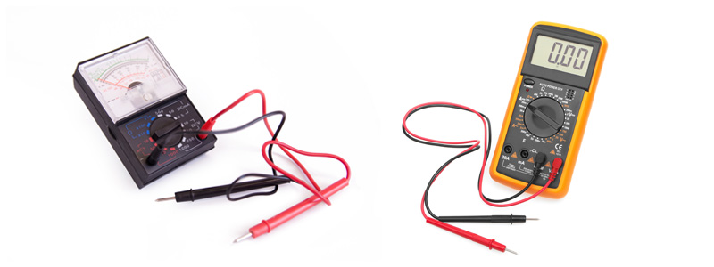

Since the voltmeter must be able to make measurements while disturbing the circuit, as little as possible voltmeters are designed to have as high resistance as possible, usually of the order of 10 MΩ (107 Ω), so they have a negligible effect on the potential differences they are measuring.

## 16.9 Experiment for Determination of Resistance

The experimental setup for finding an unknown resistance is shown in the figure below. The unknown resistance is connected in series with the ammeter while the voltmeter is connected in parallel with the unknown resistance. A variable resistance called rheostat is also connected in series with the unknown resistance and ammeter. Ensure the indicators on both the voltmeter and the ammeter align with the zero mark on their scales.

Record the full scale and smallest division value (least count) for both the voltmeter and the ammeter provided.

Engage the circuit by closing the switch and adjust the rheostat towards the position that yields the lowest current flow. Observe and make a note of the readings from both the voltmeter and ammeter. After disconnecting the circuit by opening the switch, allow the wire to return to ambient temperature.

Then, initiate the circuit again and gradually raise the voltage by changing the position of the rheostat. Record the readings of the ammeter and voltmeter.

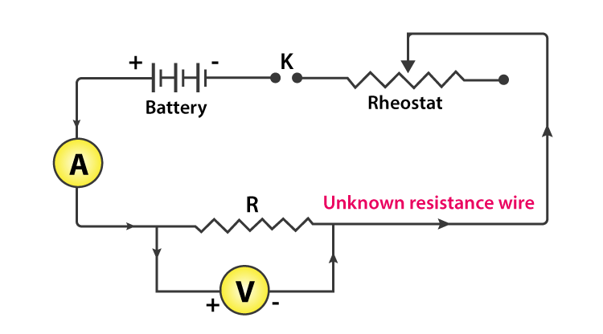

The following table can be used to record experimental readings:

| **RESISTANCE CALCULATION** | | | |
| --- | --- | --- | --- |
| **Sr. No.** | **Ammeter (A)** | **Voltmeter (V)** | **Resistance** |
| 1 |  |  |  |
| 2 |  |  |  |
| 3 |  |  |  |
| 4 |  |  |  |

Resistance Calculation: $R=\frac{V}{I}$

